**Observation Table**

| Hyperparameters | Exp No | Accu | Test | Res | Avg Accu |
| --- | --- | --- | --- | --- | --- |
| LR = 0.001, E = 0 | 1 | 0.056 | 3 | 1 | 0.2682 |
| 2 | 0.099 | 0 | 3 |
| 3 | 0.98 | 6 | 4 |
| 4 | 0.103 | 7 | 7 |
| 5 | 0.103 | 7 | 7 |
| LR = 0.001, E = 2 | 1 | 0.956 | 8 | 8 | 0.9494 |
| 2 | 0.952 | 2 | 2 |
| 3 | 0.953 | 0 | 0 |
| 4 | 0.947 | 9 | 9 |
| 5 | 0.939 | 8 | 8 |
| LR = 0.001, E = 5 | 1 | 0.967 |  | 1 | 0.9514 |
| 2 | 0.903 | 9 | 9 |
| 3 | 0.96 | 7 | 7 |
| 4 | 0.961 | 8 | 8 |
| 5 | 0.966 | 5 | 5 |
| LR = 0.001, E = 7 | 1 | 0.965 | 5 | 5 | 0.9624 |
| 2 | 0.965 | 3 | 3 |
| 3 | 0.96 | 5 | 5 |
| 4 | 0.961 | 7 | 7 |
| 5 | 0.961 | 5 | 5 |
| LR = 0.001, E = 10 | 1 | 0.967 | 3 | 3 | 0.968 |
| 2 | 0.963 | 9 | 9 |
| 3 | 0.972 | 6 | 6 |
| 4 | 0.973 | 8 | 8 |
| 5 | 0.965 | 3 | 3 |
| LR = 0.009, E = 0 | 1 | 0.099 | 0 | 0 | 0.2812 |
| 2 | 0.094 |  | 6 |
| 3 | 0.135 | 1 | 7 |
| 4 | 0.123 | 0 | 3 |
| 5 | 0.109 |  | 5 |
| LR = 0.009, E = 2 | 1 | 0.899 | 6 | 6 | 0.8972 |
| 2 | 0.886 | 0 | 0 |
| 3 | 0.886 | 6 | 6 |
| 4 | 0.905 | 8 | 8 |
| 5 | 0.91 | 6 | 6 |
| LR = 0.009, E = 5 | 1 | 0.916 | 5 | 5 | 0.906 |
| 2 | 0.899 | 6 | 6 |
| 3 | 0.916 | 4 | 4 |
| 4 | 0.914 | 8 | 8 |
| 5 | 0.885 | 8 | 8 |
| LR = 0.009, E = 7 | 1 | 0.898 | 0 | 0 | 0.8938 |
| 2 | 0.885 | 8 | 8 |
| 3 | 0.908 | 8 | 9 |
| 4 | 0.891 | 6 | 6 |
| 5 | 0.887 | 0 | 0 |
| LR = 0.009, E = 10 | 1 | 0.922 | 3 | 3 | 0.9092 |
| 2 | 0.918 | 7 | 7 |
| 3 | 0.861 | 1 | 1 |
| 4 | 0.923 | 9 | 9 |
| 5 | 0.922 | 2 | 2 |

| LR = 1, E = 0 | 1 | 0.091 |  | 5 | 0.1008 |
| --- | --- | --- | --- | --- | --- |
| 2 | 0.107 | 5 | 6 |
| 3 | 0.106 |  | 5 |
| 4 | 0.098 | 5 | 0 |
| 5 | 0.102 | 3 | 8 |
| LR = 1, E = 2 | 1 | 0.101 | 3 | 3 | 0.1038 |
| 2 | 0.098 | 5 | 0 |
| 3 | 0.103 | 7 | 7 |
| 4 | 0.114 | 3 | 1 |
| 5 | 0.103 | 4 | 2 |
| LR = 1, E = 5 | 1 | 0.089 | 8 | 5 | 0.0958 |
| 2 | 0.096 | 6 | 6 |
| 3 | 0.096 | 7 | 6 |
| 4 | 0.101 | 0 | 9 |
| 5 | 0.097 | 8 | 8 |
| LR = 1, E = 7 | 1 | 0.089 | 6 | 5 | 0.1068 |
| 2 | 0.103 | 2 | 7 |
| 3 | 0.114 |  | 1 |
| 4 | 0.114 | 5 | 1 |
| 5 | 0.114 | 1 | 1 |
| LR = 1, E = 10 | 1 | 0.101 | 9 | 9 | 0.0976 |
| 2 | 0.101 | 0 | 9 |
| 3 | 0.096 | 4 | 6 |
| 4 | 0.089 | 7 | 5 |
| 5 | 0.101 | 5 | 9 |

**Graph**

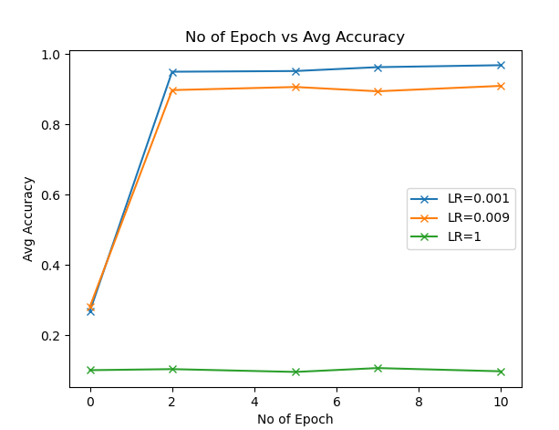

**Observation**

I saw a general trend that with a lower learning rate, keeping a high epoch gives higher accuracy.

Although having high accuracy does not mean that we cannot get lower results as seen in the observation table. Even the correct and wrong result differs for the same accuracy given that the learning rate and epoch are the same in both cases.

I got the best result by keeping LR = 0.001 and Epoch = 10. The worst result was seen at LR = 1 and Epoch = 5

There was another observation I made about the time taken by the model. For low epochs, the time was less but with bad accuracy and wrong results. The time taken by the model with same LR and epochs in different experiments no decreased for eg if exp no 1 took 2 mins then the exp no 5 took 1 min. But in some cases, this was not true.